# **Method**

## Environment setting

We set up a riverine environment with seashell population A upstream and seashell population B downstream, with the same species in both populations. There is a stable source of pollution between the upstream and downstream, which continuously discharges cyclic hydrocarbon pollutants to the downstream, so there is population decay and mutation in the downstream. However, as the river flows, some individuals from the upstream population migrate downstream, and the downstream population recovers as a result.

## Dynamic changes of population genotypes

We used R studio to model intergenerational changes in genotype of B population. This is modeled by plotting Poisson random variables based on the expected absolute number of wild-type individuals, combining the decay rate of the wild type, the selection advantage of the mutant, and the constant mutation rate, from the number of wild types to the number of mutations as Poisson random variables. We set the initial individual of the wild type as 1000, the mutation type as 0, the environmental carrying capacity as 1000, the decay rate under the influence of pollution as 0.1, the coefficient of natural selection as 0.3, the mutation rate as 0.001, and the migration individual as 3 per generation. It is worth noting that in this process, we must ensure that the coefficient of natural selection is greater than the decay rate, otherwise the population will not recover but tend to extinction.

## Tracking population dynamics as migration numbers change

In order to answer our biological questions, we must track the time it takes for populations to recover to their maximum carrying capacity at different migration levels to see how migration levels affect population recovery and the proportion of different genotypes in the population. After all parameters are set to the above values and run once, we can get the time when the population recovers to the carrying capacity when a specific number of migrations is made. On this basis, the number of migrations was set as a variable, and background values of different pollution levels with decline rates of 0.15 and 0.2 were added to increase the visibility of population changes under different backgrounds. In addition, we tried to test the number of different genotypes in each time period to see which genotype dominated the current population recovery.

## Effects of pollution degree and mutation rate on population

We also considered competition within the polluted area and the potential for mutation, with the idea that mutants are more resistant to contaminants. Based on the parameters in the method 2, we take the decay rate (under pollution) and the mutation rate as variables respectively to visualize their effects on population dynamics.

# Result

## Intergenerational changes in population size and genotype

As can be seen from the figure 1, after experiencing a low point, the population size that had been gradually dying began to recover gradually, and the mutants began to dominate the process of evolutionary rescue. Under the joint action of migrating individuals and gene mutations, the population gradually recovered to the upper limit of carrying capacity.

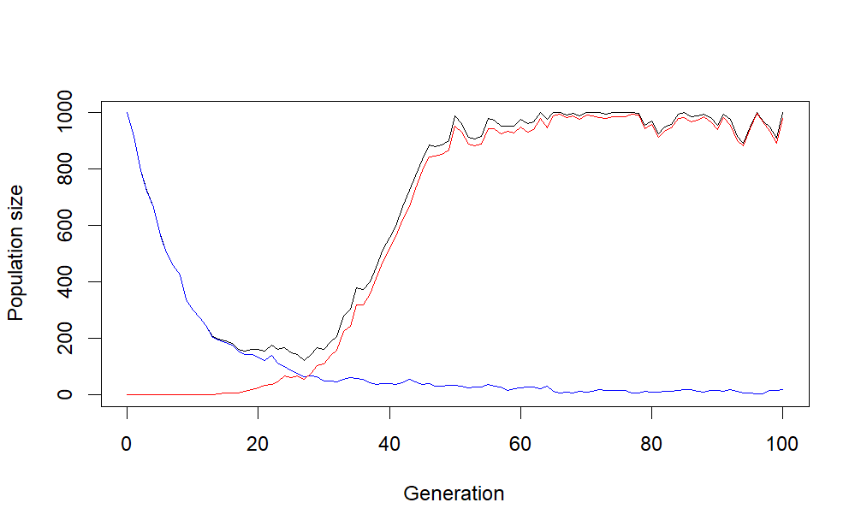

Figure 1. Intergenerational changes in population size and genotype. Black line, blue line, red line means total population size, the number of wild type and the number of mutation type respectively.

## Population dynamics as migration numbers change

After we use the number of migrants as a variable and plot the "time to carrying capacity – mean number of migrants" relationship for three different decay rates, we can see the following results.

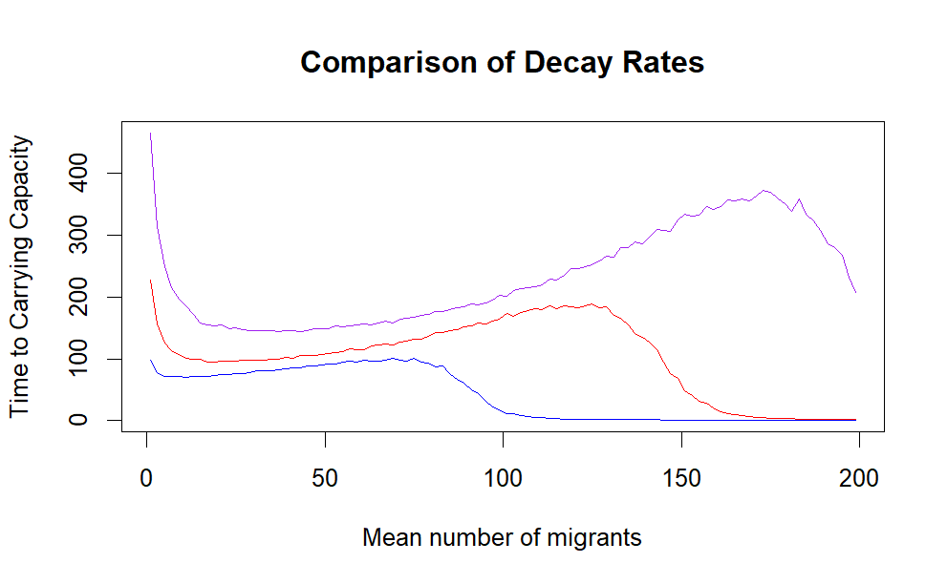

Figure 2. Population dynamics changes with the mean number of migrants at different decay rates. Blue line, red line, purple line means decay rate = 0.1, 0.15 and 0.2 respectively.

At first of figure 2, the population recovered to the carrying capacity significantly faster due to the input of migrants, but with the further increase of the number of migrants, the time to reach the carrying capacity gradually increased. But after a turning point, the rate of population recovery increases with the number of migrants, until the number of migrants in each generation can easily supplement the number of deaths in each generation (it means the number of immigrants and deaths in each generation is almost equal, reaching a steady state).

We hypothesized that in the process of decreasing the speed of reaching the carrying capacity limit with the increase of the number of migrations, the mutation rate was constant, and at the same time, the intraspecific competition and genetic dilution were increased, which made the wild type squeeze the living space of the variant, reducing the efficiency of population recovery and evolutionary rescue. To verify our hypothesis, we made some modifications to the model (increasing the mutation rate to 0.005) to observe the model change.

In figure 3, it is obvious that after modifying the mutation rate, while the time to reach the carrying capacity is greatly shortened and the process of increasing the time to reach the carrying capacity with the increase of the number of migrants is also shortened.

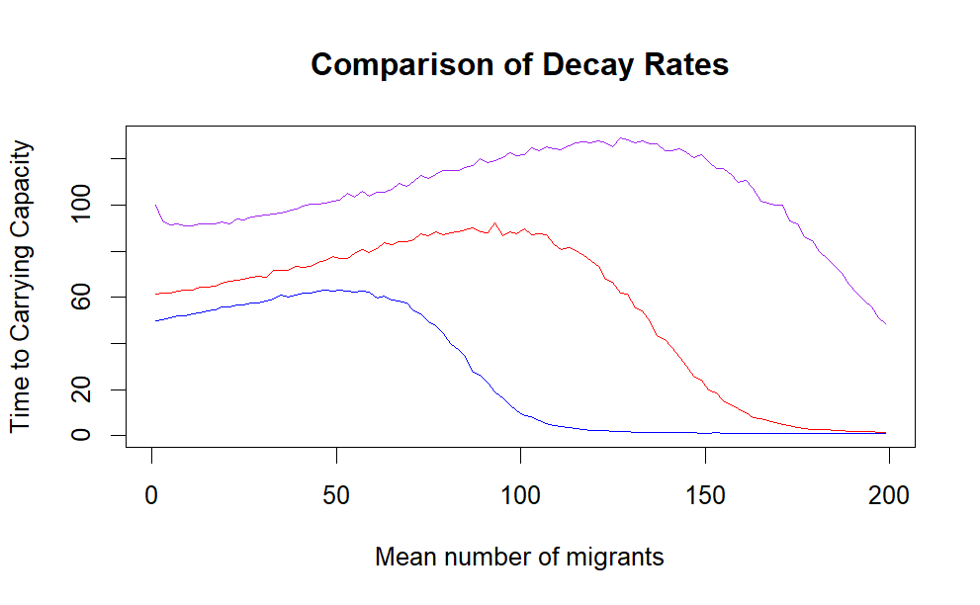

Figure 3. Population dynamics changes with the mean number of migrants at different decay rates. Blue line, red line, purple line means decay rate = 0.1, 0.15 and 0.2 respectively. (mutation rate = 0.005)

In addition, we also made the number of different genotypes for all migration numbers, and we can conclude from Figure 4 that below a certain threshold value, evolutionary rescue is led by mutants, and after this threshold value, the process becomes wild types-led population recovery.

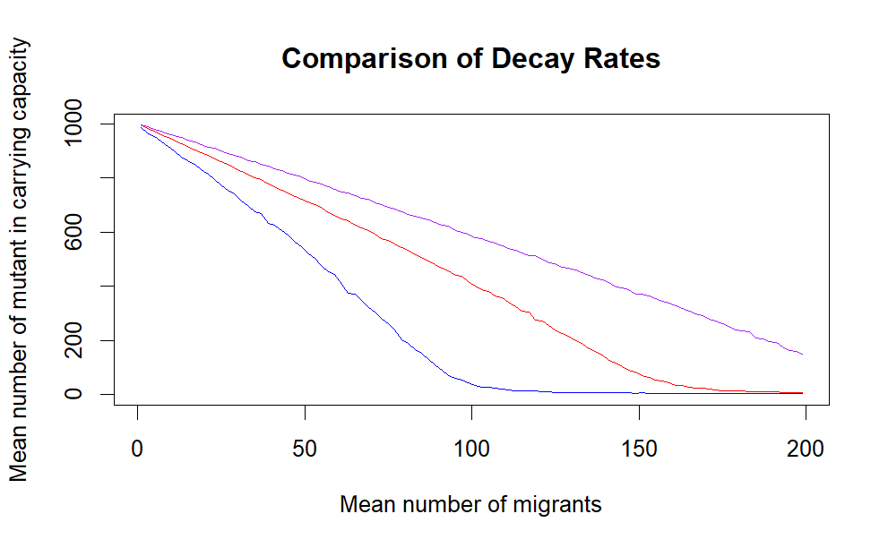 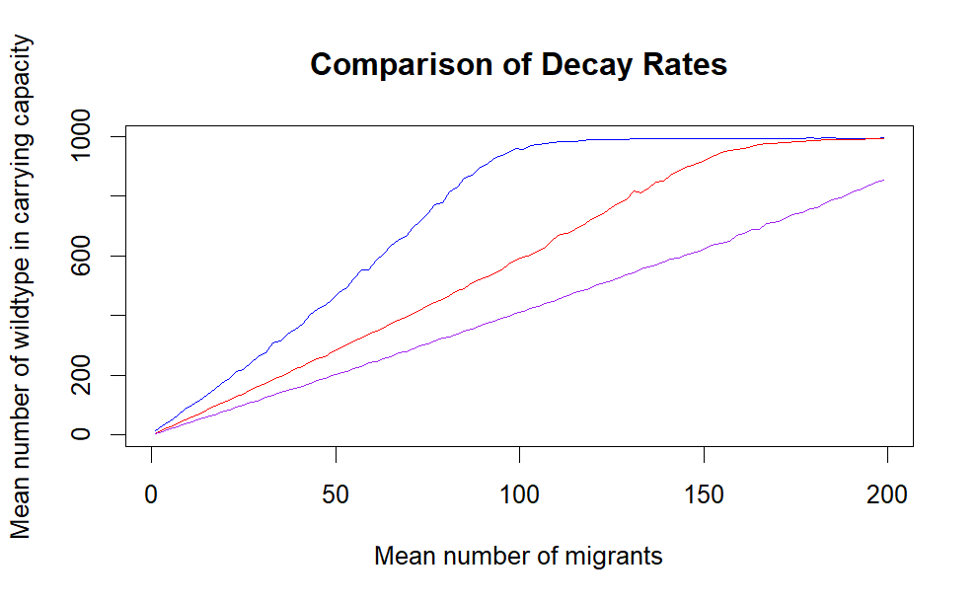

Figure 3. The number of different genotypes in the above model. Blue line, red line, purple line means decay rate = 0.1, 0.15 and 0.2 respectively. (mutation rate = 0.001)

## Population dynamics change under different pollution degree and mutation rate

We set the mutation rate and decay rate as variables respectively to get Figure 5 and Figure 6, where the upper limit of decay rate is set at 0.3 to ensure that mutation and natural selection can occur, otherwise the population will tend to be extinct.

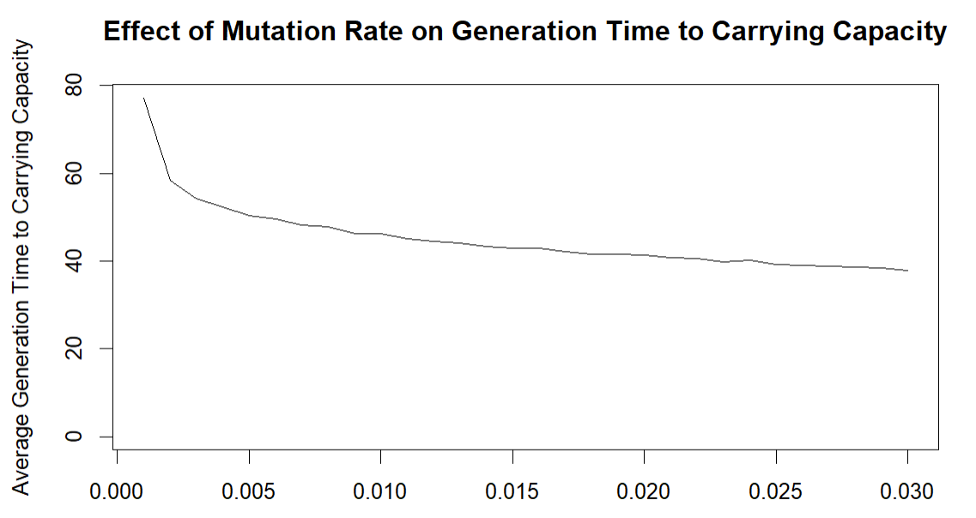

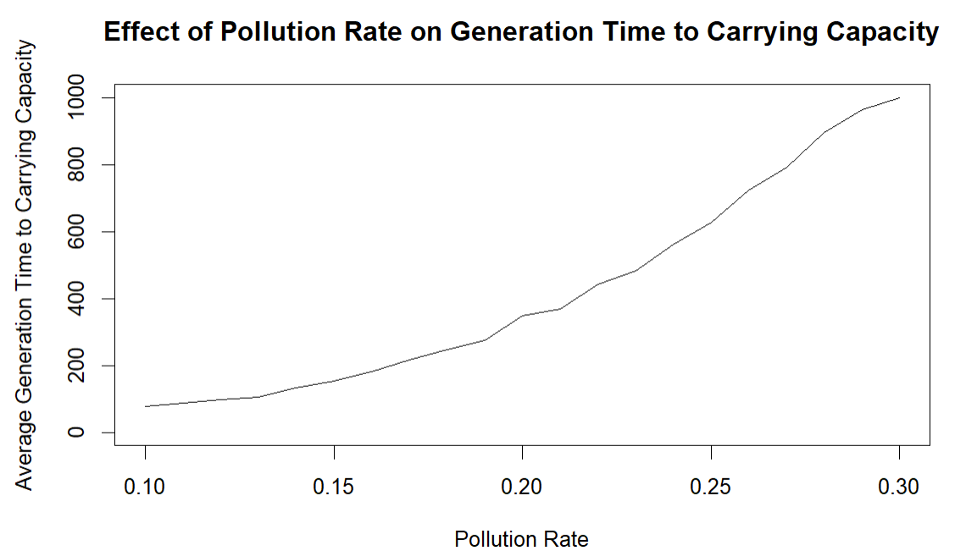

# Conclusion

In this study, we used a series of models to describe the impact of migrants on population dynamics, and compared population dynamics changes under different environmental pressures and variation potential to answer our biological question of "Can migrating individuals promote population recovery when considering the intraspecific competition, environmental pollution and variation potential?"

The results show that migrating individuals can indeed help the evolutionary rescue of the population, but with the increase of migration number, the efficiency of evolutionary rescue will become less due to the action of intraspecific competition and genetic dilution. As the number of migrations reaches the threshold of the wild-type dominant population recovery process, the efficiency of population recovery will be greatly improved, but we can hardly call this process "evolutionary rescue" because natural selection and variation will no longer be the dominant role in population recovery. At the same time, by changing the environmental pressure and the variation rate respectively, we can see that with the increase of environmental pressure, the efficiency of population recovery will significantly slow down or even tend to extinction, while with the increase of the variation rate, the efficiency of population recovery will slowly rise.

Although we got the results we wanted, there were some shortcomings in the study. We do not take into account the interaction of multiple variables, such as the effects of different migration numbers, environmental stress, and mutation rates in a single model. We may take this into account in future studies, and in addition, we need to generalize the model to other environments.